WEB SERVER DIRECTORY LISTINGS
SOLUTION 1: Use Default Index Files (index.html)
Example (Before Fix)
Directory structure:
/uploads/
├── resume.pdf
├── profile.png
User visits:
https://xyz-abc.com/uploads/
Server shows file list.

Example (After Fix)
Directory structure:
/uploads/
├── index.html
├── resume.pdf
├── profile.png
User visits:
https://xyz-abc.com/uploads/
Server loads:
index.html

What technically changed?
- The server checks for an index file first
- Since it exists, directory listing is never triggered

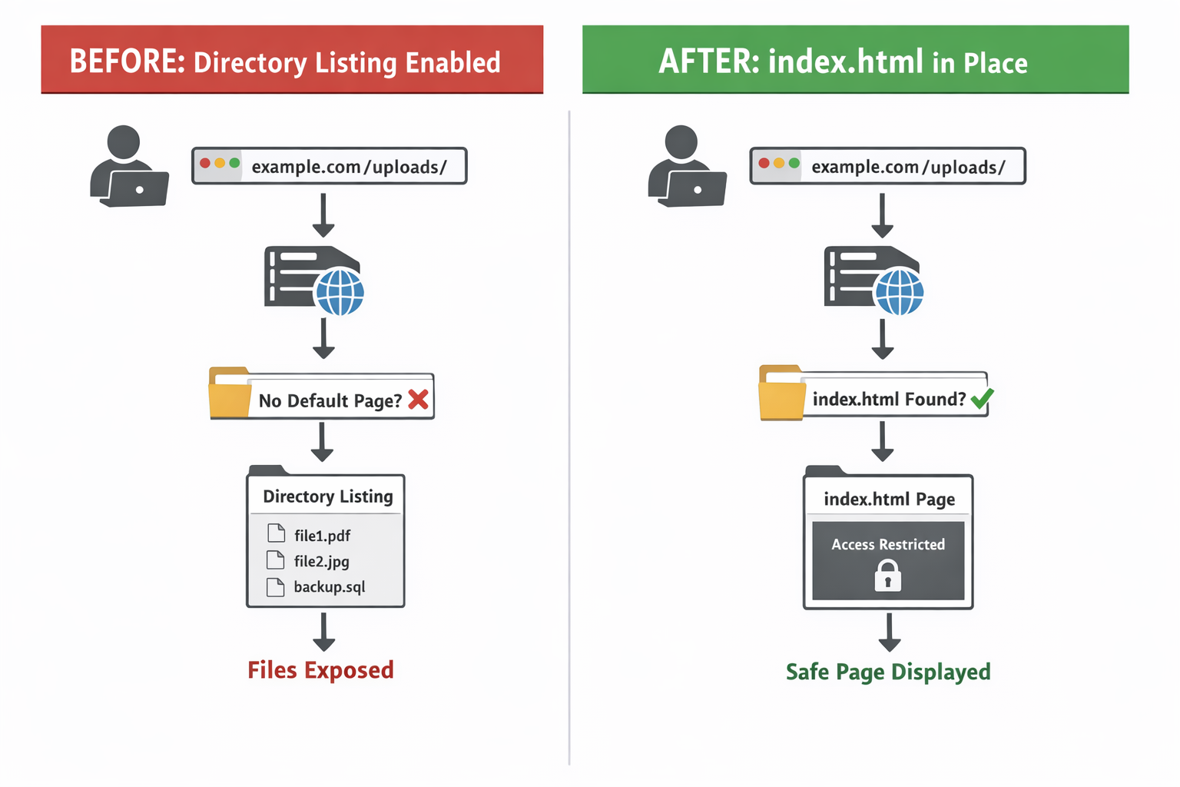

Solution 2: Separate Web Content from Internal Files (Architecture Fix)
Example (Before Fix)
Everything is stored under the web root:
/public_html/
├── index.html
├── config.env
├── db_backup.sql
├── logs/
Attacker can access anything if misconfigured.

Example (After Fix)
Clear separation:
/public_html/ ← web server can access
├── index.html
├── images/
├── css/
/app_internal/ ← NOT web-accessible
├── config.env
├── db_backup.sql
├── logs/

Attacker tries:
https://abc-xyz/db_backup.sql
Result:
File does not exist from the web’s perspective
What technically changed?
- Web server is restricted to serve only /public_html/
- Sensitive files are physically outside web reach
- No configuration mistake can expose them
